**What Is Tkinter?**

**Tkinter** is actually an inbuilt **Python** module used to create simple **GUI** apps. It is the most commonly used module for **GUI** apps in the **Python**.

You don’t need to worry about installation of the **Tkinter** module as it comes with **Python** default.

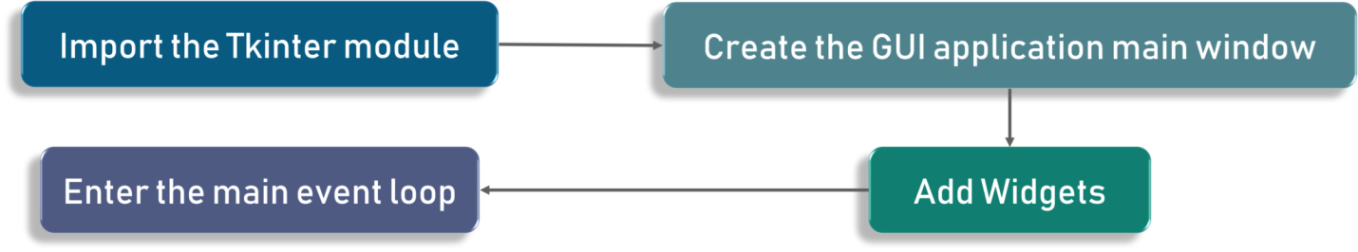

Steps to start:

1. Import Tkinter module.
2. Create main window
3. Add widgets
4. Main Event Loop. (An event loop is basically telling the code to keep displaying the window until we manually close it. It runs in an infinite loop in the back-end.)

Check out the following code for better clarity:

fromtkinter import *

window =Tk()

# to rename the title of the window window.title("GUI")

# pack is used to show the object in the window

label =Label(window, text ="Hello World!").pack()

window.mainloop()

output:

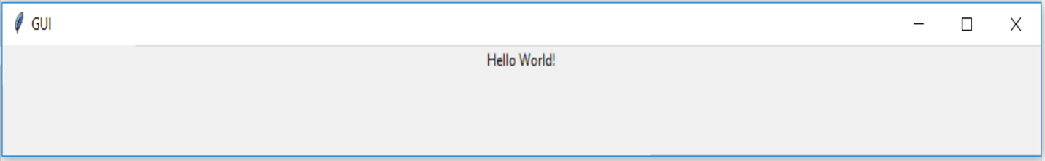

## ****Tkinter Widgets****

**Widgets** are something like elements in the **HTML**. You will find different types of **widgets** to the different types of elements in the **Tkinter**.

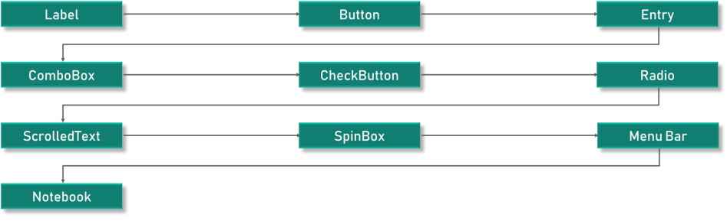

* **Canvas**– **Canvas** is used to draw shapes in your **GUI**.
* **Button**– **Button** widget is used to place the buttons in the **Tkinter**.
* **Checkbutton**– **Checkbutton** is used to create the check buttons in your application. Note that you can select more than one option at a time.
* **Entry**– **Entry** widget is used to create input fields in the **GUI**.
* **Frame**– **Frame** is used as containers in the **Tkinter**.
* **Label**– **Label** is used to create a single line widgets like **text**, **images etc.**
* **Menu**– **Menu** is used to create menus in the **GUI**.

## ****Label Widget:****

## ****Code snippet:****

l1 = Label (window, text="edureka!“ font=("Arial Bold", 50))

l1.grid (column=0, row=0)

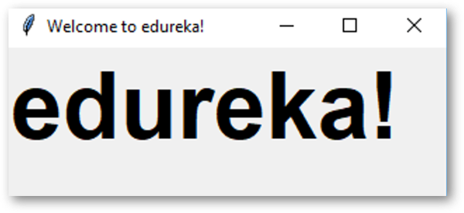

## ****Code snippet:****

l1 = Label (window, text="edureka!“ font=("Arial Bold", 50))

window.geometry('350x200')#we have set it to be 350 pixels in width and 200 #pixels in height.

l1.grid (column=0, row=0)

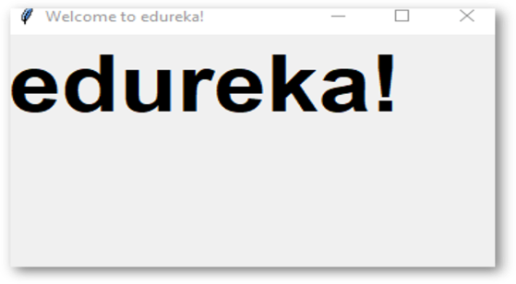

## ****Button Widget:****

Check out the below code snippet:

|  |  |
| --- | --- |
|  | bt =Button (window, text="Enter")   bt.grid (column=1, row=0)#**the grid function which is used to set the position of the #button on our window.** |
|  | Tkinter Tutorial - Edureka  Check out the code:   |  |  | | --- | --- | |  | bt =Button (window, text="Enter", bg="orange", fg="red")  Tkinter Tutorial - Edureka  bt.grid (column=1, row=0) |   What happens when we actually go ahead and click it?  defclicked():         l1.configure (text="Button was clicked !!")    bt =Button (window, text=“Enter”, command=clicked)#calling clicked() on clicking the button  We need to write the functionality as to what should happen when we click the button or in other terms when the click event is fired ****Entry Widget:**** It is used to create input fields in the GUI to take in textual input.  Check out the example code shown below:   |  |  | | --- | --- | |  | txt = Entry(window,width=10)    txt.grid(column=1, row=0)    defclicked():          res ="Welcome to "+txt.get()          l1.configure(text=res)    bt =Button (window, text=“Enter”, command=clicked) |   Tkinter Tutorial - Edureka. ****Combobox Widget:****A drop-down menu with certain options. fromtkinter.ttk import*  combo =Combobox(window)  combo['values']=(1, 2, 3, 4, 5, "Text")  combo.current(3)  combo.grid(column=0, row=0) Tkinter Tutorial - Edureka<https://www.edureka.co/blog/tkinter-tutorial/#z3> **Checkbutton Widget:**  Code snippet:   |  |  | | --- | --- | |  | chk_state = BooleanVar()  chk_state.set (True)  chk = Checkbutton(window, text=‘Select', var=chk_state)# var=chk_state keeps #button selected  chk.grid(column=0, row=0) | |  | Tkinter Tutorial - Edureka | | **Radio Button Widget:** | take a look at the code:   |  |  | | --- | --- | |  | rad1 = Radiobutton(window, text=Python', value=1)  rad2 = Radiobutton(window, text=Java', value=2)  rad3 = Radiobutton(window, text=Scala', value=3)  rad1.grid(column=0, row=0)  rad2.grid(column=1, row=0)  rad3.grid(column=2, row=0) | |   **Scrolled Text Widget:**    You can set the scrolled text content by using the insert method. The syntax is pretty simple. We need to use **txt.insert** with the message as a parameter.  Code:   |  |  | | --- | --- | |  | from tkinter import scrolledtext  txt = scrolledtext.ScrolledText(window, width=40,height=10) | |
|  |  |